"Join RentalMeet's Venue Ambassador Program and start earning today."  Join India's Fastest Growing Venue Network as a  “Venue Ambassador”  "No investment. No experience needed. Just find venues and start earning."  “AnyTime….Any Where” | 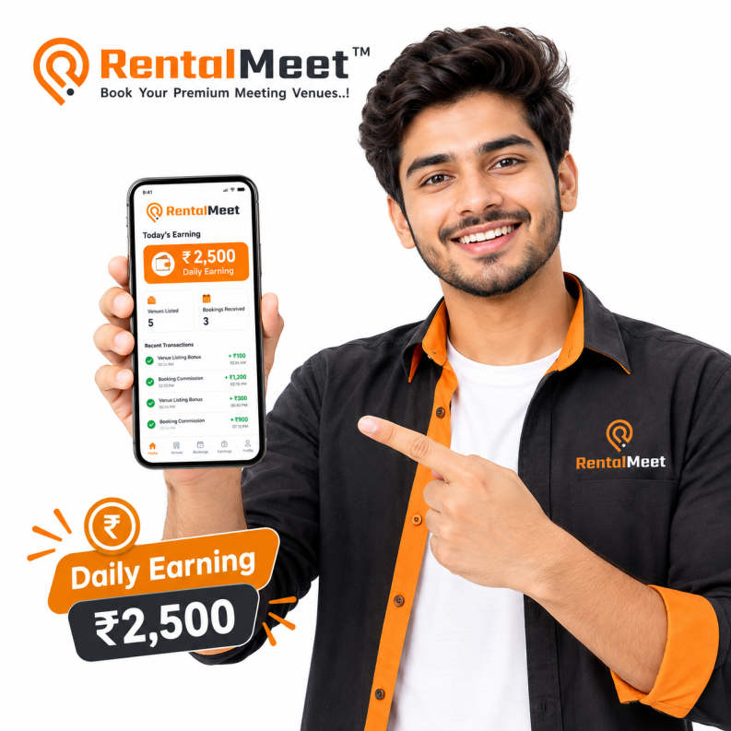
- Earn Rs.100 to Rs.200 per Verified Venue + Daily Bonus + Weekly/Monthly Incentive  - Additional - 25% Recurring Profit Share “Royalty Income” on bookings for 12 months. (Requires 7-Days or 30-Days Streak for unlock) | Register Now

TIERED GROWTH LADDER
Venue Listing Income Structure
As you list more verified venues, your earning rate automatically increases from Rs.100 to Rs.200 per venue!
Level-1 (Starting Level)  Venue Ambassador  (0–50 Verified Venues)  Payout  Rs. 100/- Per Venue  + Bonus  + Weekly/Monthly Incentive  + 25% of Royalty Income | Level-2 (+25% Higher Payout)  Venue Explorer  (51–100 Verified Venues)  Payout  Rs. 125/- Per Venue  + Bonus  + Weekly/Monthly Incentive  + 25% of Royalty Income | Level-3 (+50% Higher Payout)  Venue Champion  (101–150 Verified Venues)  Payout  Rs. 150/- Per Venue  + Bonus  + Weekly/Monthly Incentive  + 25% of Royalty Income | Level-4 (+100% Higher Payout)  Venue Master  (150+ Verified Venues)  Payout  Rs. 200/- Per Venue  + Bonus  + Weekly/Monthly Incentive  + 25% of Royalty Income

HIGH PERFORMANCE STREAKS

Daily, Weekly & Monthly Challenges
Accelerate your earnings with bonus payouts for consistent venue acquisition streaks.
DAILY STREAK  Daily 5-Venues Challenge  Minimum 5 Verified Venues in 1 Day  Sample Payout Calculation:  - 5 × Rs.100 = Rs.500/-  - Bonus 5×Rs.50 = Rs.250/-  Total Potential= Rs.750/- Per Day  *Note –  - You will get Rs. 50/- bonus for listing each venue after 5 venues in a day  - This bonus applies only to venues verified on the same day. | WEEKLY STREAK  7-Day Power Streak  5 Venues Daily or 35 Venues per Week  Sample Payout Calculation:  - 35 × Rs.100 = Rs.3,500/-  - Bonus 35×Rs.50 = Rs.1,750/-  - Fixed Incentive = Rs.1,000/-  Total Potential= Rs.6,250/- Per Week  Unlock 25% of Royalty Income for 12 Months | MONTHLY CHAMPION  30-Day Venue Champion  150 Venues in 1 Month  Sample Payout Calculation:  - 50 × Rs.100 = Rs.5,000/- (Lv-1)  - 50 × Rs.125 = Rs.6,250/- (Lv-2)  - 50 × Rs.150 = Rs.7,500/- (Lv-3)  - Bonus 150×Rs.50 = Rs.7,500/-  - Fixed Incentive = Rs.5,000/-  Total Potential= Rs.36,250/- Per Month  Unlock 25% of Royalty Income for 12 Months

7-DAYS or 30-DAYS POWER STREAK UNLOCKABLE REWARD
25% Share of Platform Profit For 1 Full Year (365 Days)
Your earning does not stop at venue listing. Complete your 7-Days or 30-Days Power Streak to unlock a 25% cut of RentalMeet's profit on every customer booking across all your listed venues for a full 12 months (1 Year).

*Terms & Condition
STREAK CONDITIONS  Daily Streak Conditions  - The 5 venues must be verified on the same calendar day.  - All venues must meet RentalMeet's verification standards.  - Venues must be new (not previously listed on RentalMeet).  - Payouts are processed weekly after verification.  Weekly Streak Conditions  - Ambassador must maintain consistent daily activity (minimum 5 venues/day).  - If a day is missed, the weekly streak bonus may be reduced or forfeited.  - Weekly payouts are processed every Monday for the previous week.  Monthly Champion Conditions  - The 150 venues must be verified within a single calendar month.  - All venues must meet verification standards.  - Monthly awards are announced on the 1st of the following month. | ROYALTY CONDITIONS  - Royalty applies only to venues listed by the Ambassador.  - Royalty is calculated on the Platform Fee, not the total booking amount.  - Royalty is paid monthly after booking completion and payment realization.  - If a venue is removed from RentalMeet, royalty on that venue ceases.  - Royalty is non-transferable and non-inheritable.  - Royalty is not applicable on cancelled, refunded, or disputed bookings.  To be eligible for 25% Royalty Income, the Ambassador must:  - Complete either the 7-Day Streak OR the 30-Day Streak challenge.  - 7-Day Streak: 5 venues daily OR 35 venues per week.  - 30-Day Streak: 150 venues in 1 month.  - If neither streak is completed, the Ambassador will NOT be eligible for 25% royalty income.  - Royalty eligibility is calculated monthly based on streak completion.  - Once eligible, royalty applies to all venues listed during that streak period.  - Royalty remains valid for 12 months from the date of venue verification.  - After 12 months: No royalty will be paid on bookings for that venue.  - Royalty is not applicable on cancelled, refunded, or disputed bookings.

TERMS OF PAYOUT
- All payouts are subject to verification and approval by RentalMeet.
- Payouts are made via UPI/bank transfer only.
- Ambassadors must submit correct UPI ID or Bank Account details.
- RentalMeet is not responsible for payments lost due to incorrect bank details.
- TDS (Tax Deducted at Source) will be deducted as per applicable Indian tax laws.
- Payouts may be withheld if any fraud or misrepresentation is detected.
GENERAL TERMS  - RentalMeet reserves the right to modify the payout structure at any time with prior notice.  - All decisions regarding payouts and bonuses are final and binding.  - The Ambassador Program is subject to RentalMeet's overall Terms of Service.  - Any disputes will be subject to the jurisdiction of Bhopal, Madhya Pradesh.  - These Terms & Conditions are effective from the date of enrollment. | DISQUALIFICATION & FORFEITURE  RentalMeet reserves the right to disqualify an Ambassador and forfeit payouts if:  - False or misleading venue information is provided.  - Venues are listed without owner consent.  - The Ambassador engages in fraudulent activity.  - Multiple accounts are created by the same person.  - The Ambassador violates RentalMeet's Code of Conduct.  - Venues are found to be non-existent or duplicate.  - Inactive Ambassador: If an Ambassador does not list even 1 venue within 30 days, their Ambassador ID will be blocked/deactivated.  - Reactivation Fee: To reactivate a blocked/deactivated Ambassador ID, a fee of Rs.500/- must be paid.  - Repeated Inactivity: If the Ambassador remains inactive again for 30 days after reactivation, the ID will be permanently deactivated without refund.  - No Payouts on Blocked ID: Any pending payouts will be held until the ID is reactivated.

PAYOUT SCHEDULE
Payout Type | Frequency | Processing Time
Per-Venue Payout | Weekly | Every Monday
Daily Streak Bonus | Weekly | Every Monday
Weekly Streak Bonus | Weekly | Every Monday
Monthly Champion Award | Monthly | 1st of following month
Royalty Income | Monthly | 7th of following month

RECOGNITION & CASH PRIZES
Monthly Star Performer Awards
Every month, top-performing Venue Ambassadors across India win massive cash awards and leadership honors.
1ST POSITION  RentalMeet Star Performer  Rs. 25,000 | 2ND POSITION  RentalMeet Silver Performer  Rs. 15,000 | 3RD POSITION  RentalMeet Bronze Performer  Rs. 10,000

Terms & Conditions
ELIGIBILITY CRITERIA  - Ambassador must have 150+ Verified Venues in a single calendar month to be eligible for any award.  - Only verified and approved venues will be counted towards the 150+ venue target.  - Venues must be new listings and not previously registered on RentalMeet. | AWARD DISTRIBUTION  - Cash prizes will be credited to the winner's registered bank account within 15 working days after the month ends.  - Winners will be announced on the 1st week of the following month.  - TDS will be deducted as per applicable Indian tax laws.
SELECTION PROCESS  - Winners will be selected based on the highest number of verified venues in a month.  - In case of a tie, the Ambassador with the higher conversion rate (bookings generated) will be preferred.  - If the tie still persists, the Ambassador who completed the verification earlier will be ranked higher. | GENERAL CONDITIONS  - RentalMeet reserves the right to verify all claims before awarding prizes.  - Any fraudulent activity will lead to disqualification and forfeiture of the award.  - Awards are non-transferable and non-negotiable.  - RentalMeet's decision regarding award selection is final and binding.  - These terms are subject to change with prior notice.

How It Works
Start earning in 6 easy steps with zero complicated paperwork.
01  Apply as Ambassador  Fill the simple online application form with basic KYC and bank details. | 02  Search Nearby Venues  Discover Meeting Venues, Auditoriums, Hotels, Banquet halls, Marriage Lawns, and other Venues. | 03  Collect & Upload Info  Use our 7-step venue listing wizard to submit photos, amenities, pricing & owner contact. | 04  Admin Verification  Our team verifies the venue and documents within 24 hours | 05  7-Days Streak & 25% Share  Complete a 7-day power streak to unlock Rs. 1,000 cash bonus + 25% recurring profit share on all bookings for 1 Full Year (365 Days)! | 06  30-Days Streak & 25% Share  Complete a 30-day power streak to unlock Rs. 5,000 cash bonus + 25% recurring profit share on all bookings for 1 Full Year (365 Days)!
.

Frequently Asked Questions (FAQs)
1. What is the RentalMeet Venue Ambassador Program?
It is a program where you earn money by finding and listing venues (like hotels, banquet halls, meeting rooms) on the RentalMeet platform. You earn per verified venue, unlock streak bonuses, and get a share of the platform's profit on bookings.
2. How much can I earn per venue?
You can earn Rs. 100 to Rs. 200 per verified venue. Additionally, you get a Rs. 50 bonus for every venue listed after the first 5 venues in a single day.
3. What is the "25% Royalty Income" and how do I unlock it?
It is a 25% share of RentalMeet's platform fee earned from bookings at venues you listed. This income is paid to you for 12 months from the date the venue is verified.
To unlock this royalty, you must complete either a 7-Day Streak or a 30-Day Streak.
4. What is the difference between the 7-Day Streak and the 30-Day Streak?
- 7-Day Streak: List 5 venues daily OR 35 venues in a week. This unlocks Rs. 1,000 cash bonus + 25% royalty.
- 30-Day Streak: List 150 venues in a month. This unlocks Rs. 5,000 cash bonus + 25% royalty.
5. How long does the 25% royalty income last?
The royalty income is valid for 12 months (1 year) from the date of venue verification. After 12 months, you will not receive any royalty on bookings for that venue.
6. What happens if I don't list any venue for 30 days?
If you do not list even 1 venue within 30 days, your Ambassador ID will be blocked/deactivated. To reactivate it, you will need to pay a ₹500 reactivation fee.
7. When and how will I receive my payments?
- Per-Venue Payouts & Streak Bonuses: Processed weekly, every Monday.
- Monthly Champion Award: Processed on the 1st of the following month.
- Royalty Income: Processed monthly on the 7th of the following month.
Payments are made via UPI or bank transfer only.
8. Do I need to pay any fee to join the program?
No, there is no joining fee. The program is free to join. However, a Rs. 500 fee applies only if your ID is deactivated due to inactivity and you wish to reactivate it.
9. How are the Monthly Star Performer Awards decided?
To be eligible, you must have 150+ verified venues in a single calendar month. Winners are chosen based on the highest number of verified venues. In case of a tie, the ambassador with the higher booking conversion rate wins.
10. What are the cash prizes for the Monthly Star Performer Awards?
- 1st Position: Rs. 25,000 (RentalMeet Star Performer)
- 2nd Position: Rs. 15,000 (RentalMeet Silver Performer)
- 3rd Position: Rs. 10,000 (RentalMeet Bronze Performer)
11. Can I list any venue?
You can list meeting venues, auditoriums, hotels, banquet halls, marriage lawns, and other venues (as per our Venues Category). The venue must be new (not already listed on RentalMeet) and must meet RentalMeet's verification standards.
12. What documents do I need to submit for a venue?
You need to submit Venue complete details, Photos, Amenities, Pricing details, and Owner contact information using RentalMeet's 7-step venue listing wizard.
13. How long does it take for a venue to get verified?
After you submit the venue details, RentalMeet's team verifies the venue and documents within 24 hours.
14. Is there any penalty for providing false information?
Yes. If you provide false or misleading information, list venues without owner consent, or engage in fraudulent activity, you will be disqualified and all pending payouts will be forfeited.
15. Can I transfer my Ambassador ID or royalty income to someone else?
No. The Ambassador ID and royalty income are non-transferable and non-inheritable.
16. What happens to my royalty if a venue is removed from RentalMeet?
If a venue is removed from RentalMeet, the royalty on that specific venue will cease immediately.
17. Do I get royalty on cancelled or refunded bookings?
No. Royalty is not applicable on cancelled, refunded, or disputed bookings.
18. Which court has jurisdiction for any disputes?
Any disputes will be subject to the jurisdiction of the courts of Bhopal, Madhya Pradesh, India.

***Do not disclosed
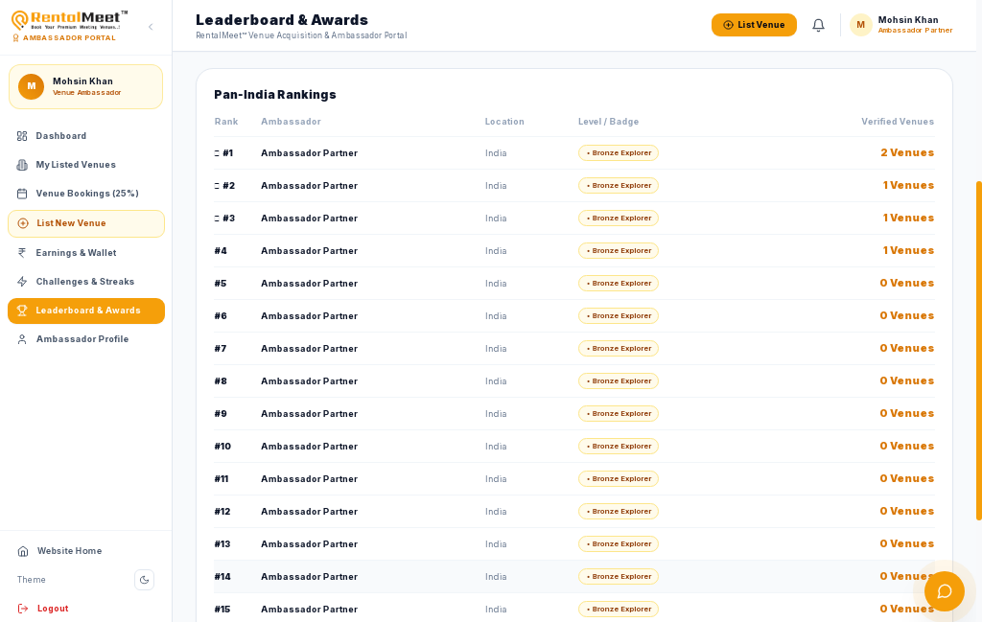

Change
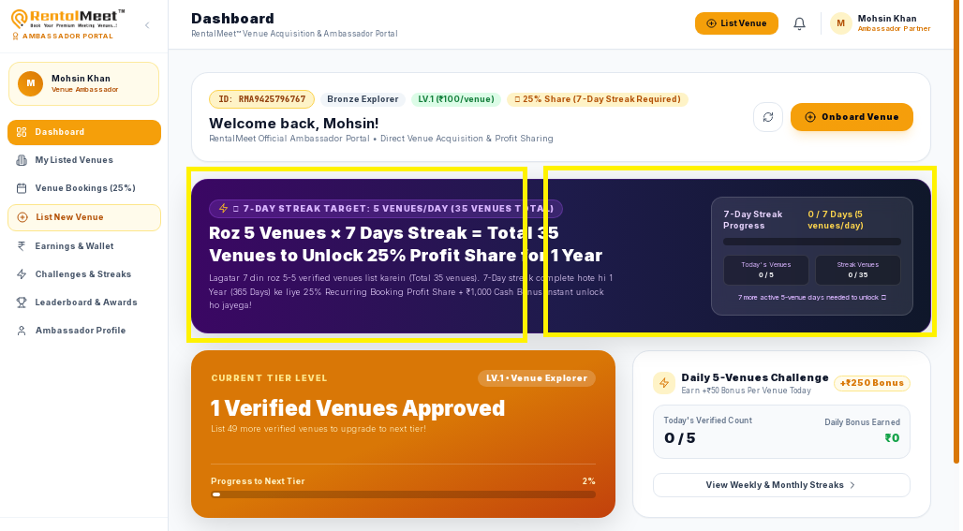
2 Cards – for 7 Days & 30 Days

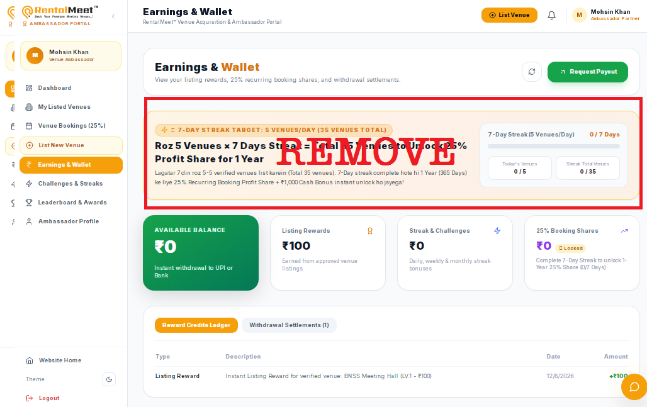

Update as per Changes
